**Video Games Sales Analysis Project**

### **1.Introduction**

Video games have become a significant part of the entertainment industry, with sales figures reflecting their widespread popularity. This report presents an analysis of video game sales data, utilizing Tableau to visualize key trends and insights. The primary objective of this project is to understand patterns in video game sales across different genres, platforms, publishers, and years.

### **2. Methodology**

#### **Data Collection:**

* Video game sales data was obtained from Kaggle source.
* Data was collected for different attributes such as game names, platforms, genres, publishers, and sales figures.

#### **Data Preprocessing:**

* The collected data underwent preprocessing, including cleaning and formatting, to ensure consistency and accuracy.

.

#### **Visualization Techniques:**

* Tableau was utilized for visualizing the data.
* Various charts and graphs were created to represent different aspects of the data, including area charts, horizontal bars, treemaps, and packed bubbles.

### **3. Requirement Analysis**

#### **Objectives:**

* The primary objective was to analyze video game sales data to identify trends and patterns.
* Specific requirements included understanding sales by genre, platform, publisher, and year, as well as identifying top-performing games and publishers.

### 4. Other Parameters depending upon the Projects

#### **Additional Parameters:**

* Zonel sales data and time period (Started year to End year)were explored to understand zonal l variations in video game consumption for particular time period.

### **5. All Visualizations**

#### **Total Sale by Genre**

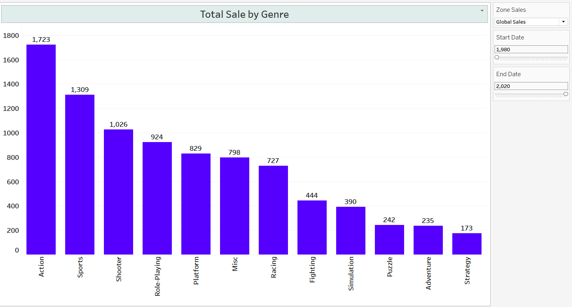

* Shows the total sales volume for each genre of video games.
* Allows for comparisons between different genres in terms of sales performance.

#### **Sales by Year & Genre**

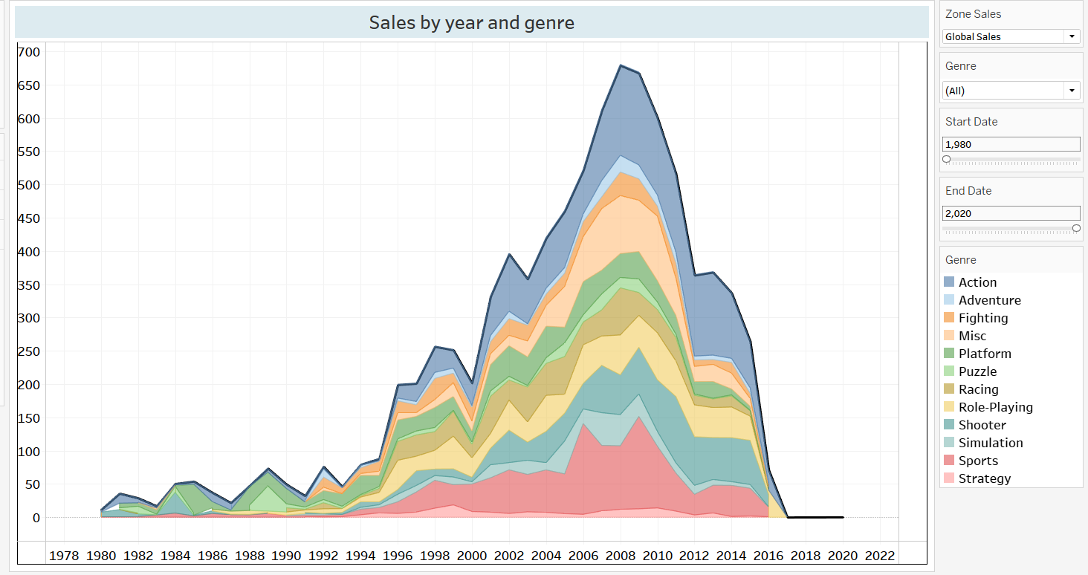

* Visualizes the trend of video game sales over the years across different genres.
* Helps identify genres that have experienced growth or decline in sales over time.

#### **Top 10 Names by Sales**

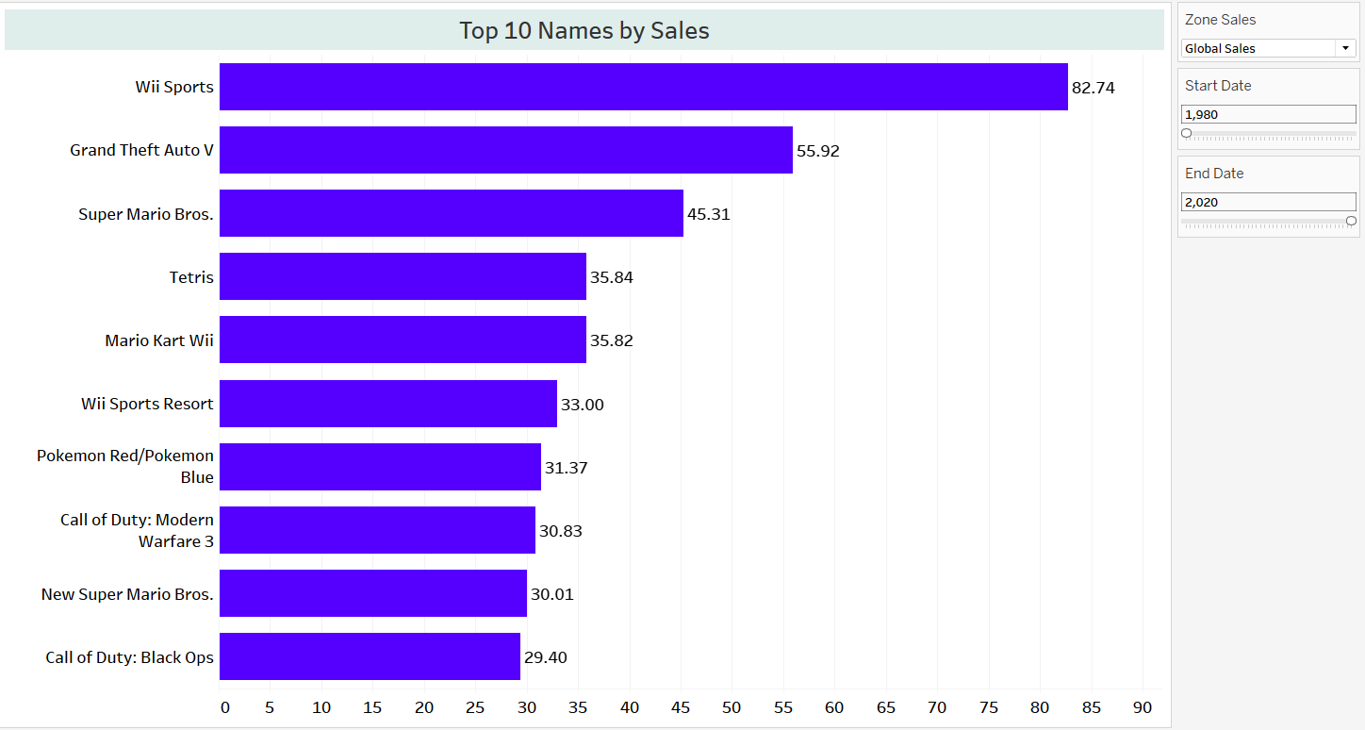

* Presents the top-selling video game titles based on total sales.
* Provides insights into the most popular games in terms of sales revenue.

#### **Top 10 Platforms by Sales**

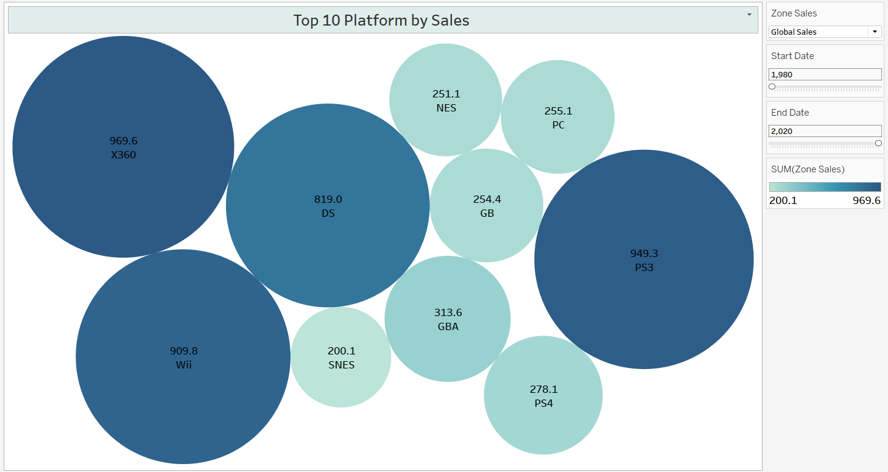

* Displays the market share of different gaming platforms based on sales figures.
* Highlights the dominance of certain platforms in the market.

#### **Top 10 Publishers by Sales**

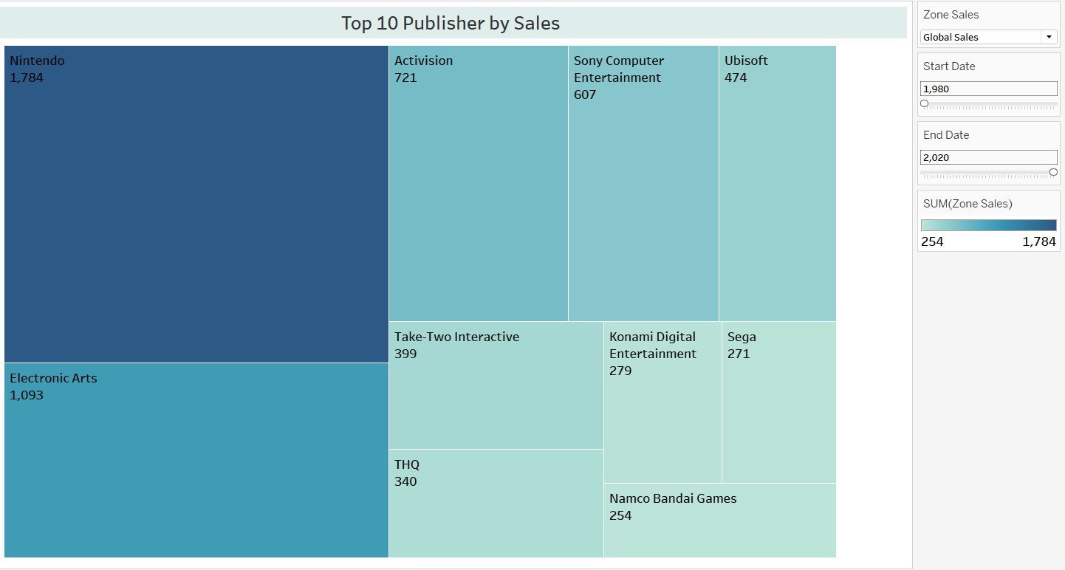

* Illustrates the distribution of sales among the top publishers in the industry.
* Facilitates comparisons between different publishers based on their sales performance.

#### **Dashboard**

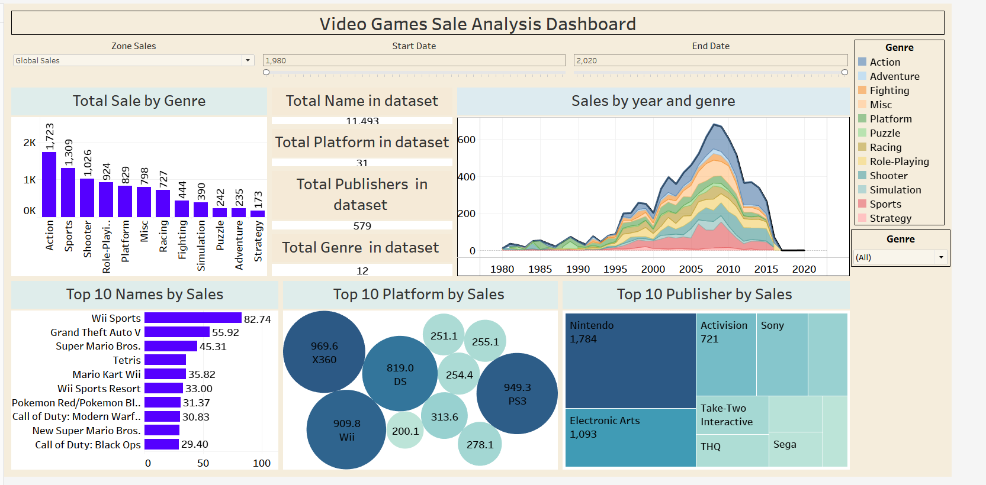

### **6. Insights from the Visualizations**

#### **Sales Trends:**

* Overall, the video game industry has experienced steady growth in sales over the years.
* Certain genres, such as action and shooter games, have consistently performed well in terms of sales.

#### **Platform Preferences:**

* Platforms, particularly PlayStation and Xbox, dominate the market in terms of sales volume.
* PC gaming also commands a significant share of the market, driven by digital distribution platforms.

#### **Publisher Performance:**

* Established publishers such as Electronic Arts and Activision consistently rank among the top performers in terms of sales.
* Independent developers also play a significant role, with several indie titles achieving notable sales success.

### **7. Conclusion**

* The analysis of video game sales data provides valuable insights into the dynamics of the industry.
* The findings highlight the importance of understanding consumer preferences and market trends in driving sales success. Moving forward, continued analysis of sales data will be essential for adapting to evolving market conditions and optimizing business strategies.